**Pizzahut Sales Report**

**KPI’s Requirement**

- We need to analyze key indicators for our pizza sales data to gain insights into our business performance.

We want to calculate following metrics

1. Total Revenue - Sum of all the total orders of pizza.
2. Average Order Value - It is calculated by dividing the total revenue by the total number of orders.
3. Total Pizza Sold - Sum of quantities of all pizza sold.
4. Total Orders - Sum of orders placed.
5. Average Pizza Per Order - It is calculated by dividing total number of pizza sold by the total numbers of orders.

**Chart Requirement**

- We would like to visualize various aspects of our pizza sales data to gain insights and understand key trends. We have identified following requirements for charts.

1. Daily Trends for Total Orders
2. Monthly Trend for Total Orders
3. Percentage of Sales by Pizza Category
4. Percentage of Sales by Pizza Size
5. Total Pizza Sold by Pizza Category
6. Top 5 Best Sellers by Revenue, Total Quantity and Total Orders
7. Bottom 5 Sellers by Revenue, Total Quantity and Total Orders

Software used -

Google Cloud Big query

Power BI - 2023 version

# Pizzahut SQL Queries - KPI’s

**1.Total Revenue -**

Select sum(total_price) as Total_Revenue from `pizzasales-409506.Pizzasales.pizzasale`

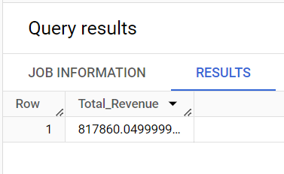

1. **Average Order Value -**

 Select sum(total_price)/ count(distinct order_id) as Average_Order_Value from `pizzasales-409506.Pizzasales.pizzasale`

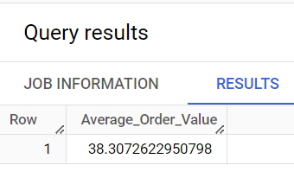

1. **Total Pizzas Sold -**

SELECT SUM(quantity) AS Total_pizza_sold FROM `pizzasales-409506.Pizzasales.pizzasale`

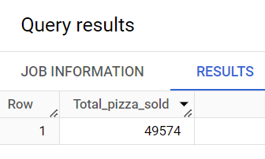

**4. Total Orders**

SELECT COUNT(DISTINCT order_id) AS Total_Orders FROM `Pizzasales.pizzasale`

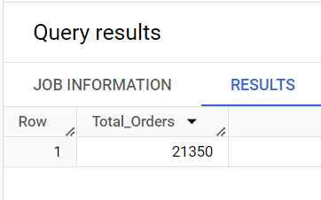

**5. Average Pizzas Per Order**

SELECT SUM(quantity) / COUNT(DISTINCT order_id)

AS Avg_Pizzas_per_order

FROM `pizzasales-409506.Pizzasales.pizzasale`

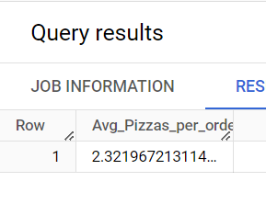

# Trends

1. Daily Trends -

SELECT EXTRACT (DAYOFWEEK FROM order_date) AS dayofweek, COUNT(DISTINCT order_id) AS total_orders

FROM `pizzasales-409506.Pizzasales.pizzasale`

GROUP BY EXTRACT (DAYOFWEEK FROM order_date)

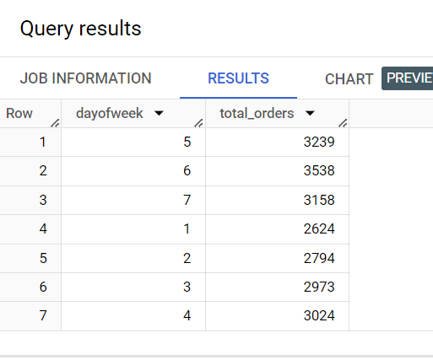

1. Monthly Trends

SELECT EXTRACT (MONTH FROM order_date) AS Month, COUNT(DISTINCT order_id) AS total_orders

FROM `pizzasales-409506.Pizzasales.pizzasale`

GROUP BY EXTRACT (Month FROM order_date)

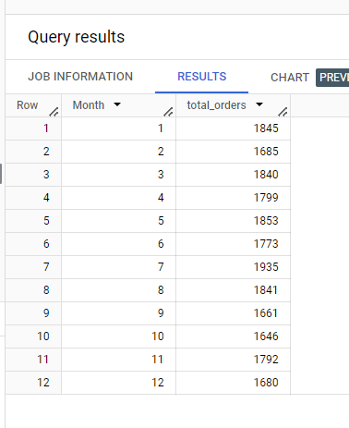

1. **Percentage of sales on Pizza Category**

SELECT pizza_category, CAST(SUM(total_price) AS int64 ) as total_revenue,

CAST(SUM(total_price) * 100 / (SELECT SUM(total_price) from `pizzasales-409506.Pizzasales.pizzasale`) AS INT64) AS PCT

FROM `pizzasales-409506.Pizzasales.pizzasale`

GROUP BY pizza_category

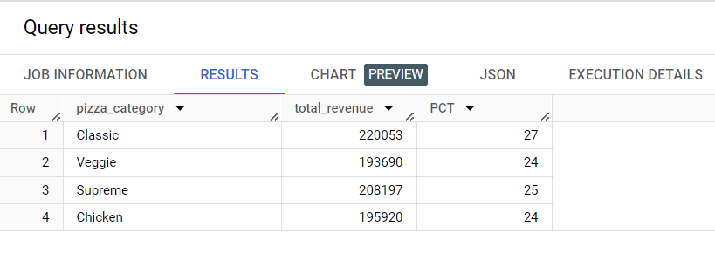

**4. % of Sales by Pizza Size**

SELECT pizza_size, CAST(SUM(total_price) AS int64) as total_revenue,

CAST(SUM(total_price) * 100 / (SELECT SUM(total_price) from `pizzasales-409506.Pizzasales.pizzasale`) AS int64) AS PCT

FROM `pizzasales-409506.Pizzasales.pizzasale`

GROUP BY pizza_size

ORDER BY pizza_size

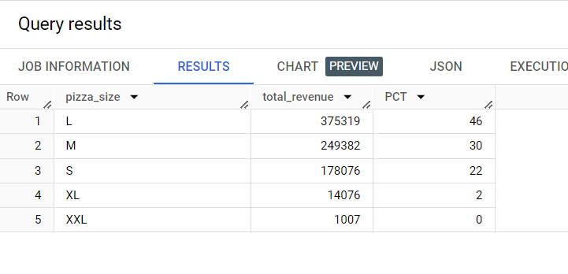

1. Total Pizza sold by category

SELECT pizza_category, SUM(quantity) as Total_Quantity_Sold

FROM `pizzasales-409506.Pizzasales.pizzasale`

GROUP BY pizza_category

ORDER BY Total_Quantity_Sold DESC

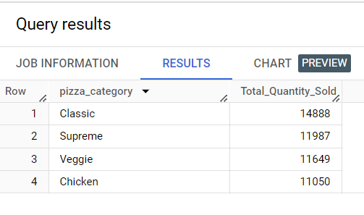

1. Top 5 Pizza by Revenue

SELECT pizza_name, SUM(total_price) AS Total_Revenue

FROM`pizzasales-409506.Pizzasales.pizzasale`

GROUP BY pizza_name

ORDER BY Total_Revenue DESC

LIMIT 5

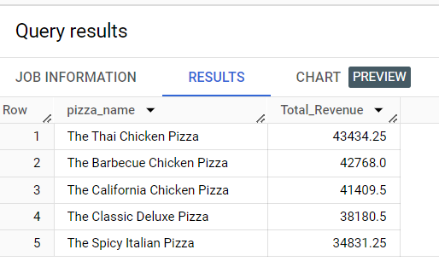

1. Bottom 5 Pizza by Revenue

SELECT pizza_name, SUM(total_price) AS Total_Revenue

FROM`pizzasales-409506.Pizzasales.pizzasale`

GROUP BY pizza_name

ORDER BY Total_Revenue ASC

LIMIT 5

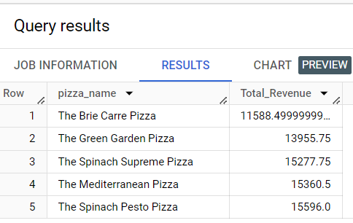

7.Top 5 Pizza by Quantity

SELECT pizza_name, SUM(quantity) AS Total_Pizza_Sold

FROM`pizzasales-409506.Pizzasales.pizzasale`

GROUP BY pizza_name

ORDER BY Total_Pizza_Sold DESC

LIMIT 5

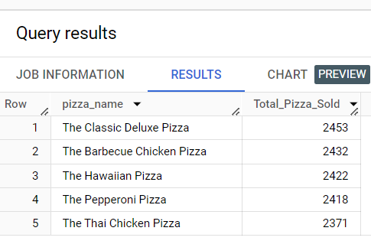

8.Bottom 5 Pizza by Quntity

SELECT pizza_name, SUM(quantity) AS Total_Pizza_Sold

FROM`pizzasales-409506.Pizzasales.pizzasale`

GROUP BY pizza_name

ORDER BY Total_Pizza_Sold DESC

LIMIT 5

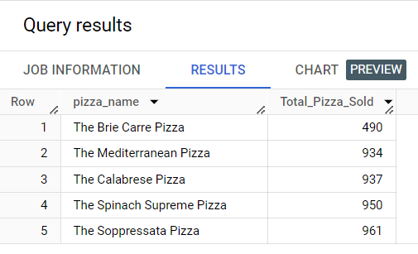

9.Top 5 Pizza by

SELECT pizza_name, COUNT(DISTINCT order_id) AS Total_Orders

FROM `pizzasales-409506.Pizzasales.pizzasale`

GROUP BY pizza_name

ORDER BY Total_Orders DESC

LIMIT 5

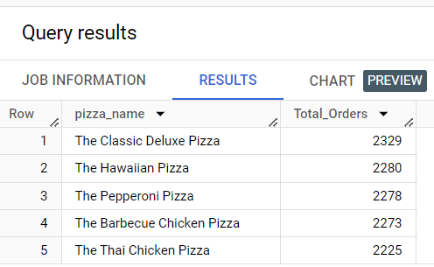

1. Bottom 5 Pizza by Total Orders

SELECT pizza_name, COUNT(DISTINCT order_id) AS Total_Orders

FROM `pizzasales-409506.Pizzasales.pizzasale`

GROUP BY pizza_name

ORDER BY Total_Orders

LIMIT 5

